

`

TOM Integration
Interface Specification
On
Store Reference Data
From IDS to GPM

[S074]

Project BEN Code: | W60416
Author: | Nitin Singhai
Date: | 17/04/2007
Version: | 0.1
Status: | Draft
Modified By:
Reviewed By:

Change Record

Author | Date | Version | Change Reference, description
Nitin Singhai | 17-04-2007 | 0.1D | Draft

Reviewers

Name | Date | Version | Position
Andrew Barker

At least one reviewer is required.

Sign-Off

By signing this form, I understand and agree with the contents of this document.

Business Owner/Customer | Andrew Barker
Position | Engagement Architect
Signature | <Physical signature or via email approval>
Date | dd/mm/yyyy (<version signed off>)

Distribution List

Name | Date of Issue | Version
Andrew Barker
John Cowper
Jon Braggs
David Onyett
Venkateswara Rao

Document Source
DocShare: UK IT/TOM Integration/Shared Documents

Related Documents

Related Documents

A complete interface specification requires three documents- an Interface Specification, an Information Architecture Context diagram, and a Mapping spreadsheet. This section identifies these documents plus other documents as appropriate.

Information Architecture Context diagram

Mapping spreadsheet
S074 Store Details from IDS to GPM Mapping Document.xls

Other Reference Documents
Table of Contents
1 Introduction 6
1.1 Purpose of Document 6
1.2 Background 6
1.3 Scope 6
2 Description and Requirements for the End-to-End Interface 7
2.1 Description of the End-to-End Interface 7
2.2 Architecture 7
2.3 Requirements for the End-to-End Interface 7
3 Processing required in an Extract-Stage of the interface 9
3.1 Scope 9
3.2 Source Message Schema 9
3.3 Sample Message Format 9
3.4 Message Transport Details 9
3.5 Naming and Configuration 10
3.6 Environment and Security Context 10
3.7 Non-Functional Requirements 10
4 Processing required in the Messaging Stage of the interface 11
4.1 Scope 11
4.2 Data Validation 11
4.3 Filtering 11
4.4 Mapping 11
4.5 Target Message Schema 11
4.6 Message Transport Details 12
4.7 Naming and Configuration 14
4.8 Environment and Security Context 14
4.9 Non-Functional Requirements 14
5 Processing required in the <third stage of the interface> 15
5.1 Scope 15
5.2 Data Validation 15
5.3 Filtering 15
5.4 Mapping 15
5.5 Target Message Schema 15
5.6 Message Transport Details 15
5.7 Naming and Configuration 15
5.8 Environment and Security Context 15
5.9 Non-Functional Requirements 15
6 Testing Deliverables 16
7 Deployment 17
8 Assumptions and Outstanding Issues 18
8.1 Assumptions 18
8.2 Outstanding Issues 18
Appendix A Volumes 19
Appendix B Glossary 20
Appendix C Document Control 21

Introduction

Purpose of Document
The purpose of this document is to describe the interfacing requirements w.r.t Store reference data between the IDS and GPM Application. The document is of a sufficiently technical nature to allow a developer to build an actual interface. Additionally the document contains detail that might sit logically within a Technical System Design (TSD) document, but is contained here for expediency. There is therefore no associated TSD for this interface.

This interface is for US implementation.

Background
As part of Tesco Operating Model program, there is requirement to bridge the functionalities of enterprise applications including IDS and GPM. To achieve this functionality, high level process flow architecture has been designed and approved by Tesco’s Enterprise Architecture team. As part of this process flow architecture there is a set of interfaces that has been identified to be developed to transfer Store Reference data from IDS into GPM.

Scope
The Interface Specification covers:

- audit requirements across the interface
- security requirements across the interface
- timing/frequency requirements or constraints
- support requirements
- archiving
- the data format to be used for the interface at each stage (e.g. xml messages)
- the normal processing required at each stage
- recovery from failure required at each stage
- volumes.

Note that it is Tesco strategy to avoid placing any business logic in integration layer processing.

Description and Requirements for the End-to-End Interface

Description of the End-to-End Interface
The interface is an extract of Store Reference Data from IDS using Common Forms and uploads into the GPM Holding Table using SSIS. The Upload is a full upload in nature.

Architecture
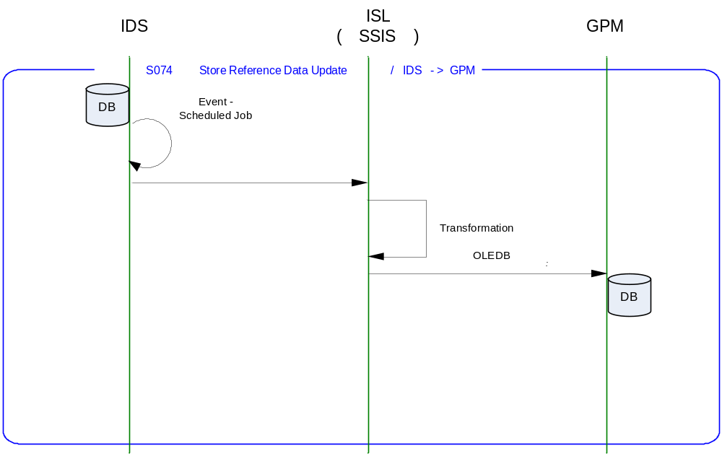

Requirements for the End-to-End Interface
The interface is meant to run nightly at a pre-configured time, which on completion is expected to upload the Store reference data in a Store Holding Table in GPM.

The interface will make use of the audit and traceability components that are being developed as part of the Operational Framework stream. Developers should put a ‘placeholder’ in their code / configurations as appropriate.

The interface will make use of the audit and traceability components that are being developed as part of the Operational Framework stream. These components will be pluggable, and will be useable from BizTalk, RTI, and SSIS. At the time of writing (2007-04-17) the components are in design. Although not ready for use, they are included on the Information Architecture Context diagram where their functionality is required. Developers should put a ‘placeholder’ in their code / configurations as appropriate.

Non-Functional Requirements of the End-to-End Interface

Audit Requirements | The interface will use the components provided by the Operational Framework to satisfy audit requirements.
Security Requirements | The interface executes within a secure private domain. There are no additional security considerations required.
Timing/Cut-off Constraints | To be finalised.
Performance Requirements | The interface should be capable of extracting data from IDS using Common Forms, delivering the resulting data to GPM Store Holding Table before the identified cut-off time. The interface should run on scheduled batch basis.
Reliability and Availability Requirements | The interface-run should be atomic in nature. Appropriate mechanisms should be in place to raise/alert appropriate parties.
Scalability Requirements | No Scalability requirement. The requirement is to deliver a single extract. It is anticipated that the volume of data transferred will continue to remain within the capability provided by this implementation.
Operational Support Requirements | The successful delivery, failure in the creation of the extract, and failure in message transport, must be recorded by the Integration Management Operational Framework (IMOF). In the event of failure, an alert should be raised. Alerts will be monitored by HSC Operations and passed to support as appropriate. (Refer to 8.2 Outstanding Issues).
Likelihood of Change Requirements | There is no such requirement
Cultural/Global Consideration Requirements | Although multi-byte character set support is not required for US or Turkey, the interface will support multi-byte character sets through integration.
Legal Requirements | N/A
Compliance To Standards Requirements | No compliance exceptions.

Processing required in an Extract-Stage of the interface

Scope
This section describes the data sources required by this interface and the services used to access the data.

Source Message Schema
There is no source message as such. The source data resides in the form of RDBMS tables. The data is extracted via Location Common Form.

Message Transport Details

Feature | Specification | Additional Information
Source System Name | IDS
Source Platform / OS | Windows 2003 Server
Source Physical Location | SQL SERVER 2005
Source Underlying Data Storage Technology | RDBMS
Target System Name | SSIS
Target Platform / OS
Target Physical Location
Target Underlying Data Storage Technology | File Share
Transfer Function | HTTP (Put/Post) □  HTTPS (Put/Post) □  Message Queue □  FTP □  File Drop(Windows) □  (XCOM) □  SSIS □  Common Forms ☑
Data Format. | XML □  Delimited □  Positional □  RDBMS ☑
Decryption/Encryption | No
Decompression/Compression | No
Transmission Mode | Synchronous □  Asynchronous ☑  Bulk Data □
Real-time/Scheduled Batch | Not yet decided
Archiving | There is no requirement to archive the messages.
Logging | Log via the Operational Framework.
Error Handling | Not yet decided  Processing should prevent sending of duplicate messages, unless this occurs during recovery from failure.

Processing required in the Messaging Stage of the interface

Scope
This section describes the discreet steps within the SSIS package to extract and format data. The target schema is included in this section

Package Overview
SSIS extracts the product reference data from IDS using Common Forms, nightly at predefined time. In turn, the data is inserted into a Holding table in GPM Database which is the Store Holding Table.

Filtering
There is no filtering requirement.

Mapping
Mapping document will be provided subsequently.

Target Message Schema
Holding Table Field Name | Type | Length | Notes / Transformations
StoreId | Integer | 4 | This field will contain the store id of a store.
StoreFormat | Varchar | 10 | Description of type of store for e.g. Metro or PFS.
StoreSubnet | Varchar | 20
ParentStoreID | Integer | 4 | This field will contain the store number of the store with which this store is mapped to e.g. a PFS is mapped to main store.
IL_TimeStamp | Datetime |  | TimeStamp to be used Internally by GPM Application

Message Transport Details
For messages destined for GPM system, the following applies.

Feature | Specification | Additional Information
Source System Name | SSIS
Source Platform / OS
Source Physical Location
Source Underlying Data Storage Technology
Target System Name | GPM
Target Platform / OS | SQL Server 2005
Target Physical Location
Target Underlying Data Storage Technology
Transfer Function | HTTP (Put/Post □  HTTPS (Put/Post) □  Message Queue □  FTP □  File Drop (Windows) □  (XCOM) □  RTI File Adapter □  SSIS ☑
Data Format | XML □  Delimited □  Positional □  RDBMS ☑
Decryption/Encryption | No
Decompression/Compression | No
Transmission Mode | Synchronous □  Asynchronous ☑  Bulk Data □
Real-time/Scheduled Batch | RDBMS extract
Archiving | There is no archiving requirement
Logging  Should logs be kept of all actions? For how long should these be stored? | Logging should occur, such that the message can be recreated if necessary.
Error Handling | Not yet decided  Processing should prevent sending of duplicate messages, unless this occurs during recovery from failure.

Naming and Configuration

SSIS
Package Name: TOM.S074.IDStoGPM.StoreDetails.dtsx
Instruction Details
Description | To be determined
Enabled | True
Type
Operational Window
Schedule | N/A
Enabled | False
Host Details
Account | To be determined
Operational Details
Worker Threads
Priority
Batch Size
Period
Retry Attempts
Timeout
Require Data Send
Exception Management
Treat Fatal Adapter Exception As
Treat Unhandled Exceptions As

Environment and Security Context
Account details will be included here once we have visibility of the environments.

Non-Functional Requirements
On successful delivery of the data to the target system, the audit log should be updated via the Operational Framework pipeline component or adapter (to be determined).

In the event of a failure of transformation of data should be written to the failed log database, and an alert should be raised.

Processing required in the <third stage of the interface>

Scope
There is no intermediate staging is required for this interface. So this section is not applicable.

Data Validation
Not Required

Filtering
Not Required

Mapping
Not Required

Target Message Schema
Not Required

Message Transport Details
Not Required

Naming and Configuration
Not Required

Environment and Security Context
Not Required

Non-Functional Requirements

Not Required

Testing Deliverables
Unit Test Scripts and test cases are kept at the following location <location>

Deployment

Assumptions and Outstanding Issues

Assumptions
ID | Assumption
1 | Target Holding Table Details are not available. Data type and length of fields of destination table Store Holding Table are based on the core table tbl_Store.

Outstanding Issues
ID | Issue | To be addressed by
1 | GPM Store Holding Table generation script to be provided. Using dummy Store holding table (name, datatypes and size based on tbl_Store core table in GPM) may result in rework if there are significant changes when final script issued from GPM. | GPM Team
2 | Timings and cut-off constraints need to be defined. Require input from SRD. | Space, Range, Display Solution Architects plus Information Architect
3 | Deployment not yet considered | Information Architect
4 | Alert numbers/identifiers are yet to be defined | Information Architect
5 | The design of the IMOF is still being worked and will require retro-fitting to the interface | Information Architect
6 | Specific IMOF event identifiers are yet to be defined | Information Architect

- Volumes
- Glossary

Acronym | Term | Description
EAI | Enterprise Application Integration | The process of meeting the data requirements of applications by providing a message based transport from disparate data sources across all forms of enterprise technology.
EAI Layer | Enterprise Application Integration Layer | Refers to the integration services provided to implement EAI. In contrast to the EIA Layer for data services. See below.
EIA | Enterprise Information Architecture | Creation of a strategic single view of data across the enterprise.
Interface | Interface | Many definitions exist for 'interface'. In general, 'interface' refers to the link between a data source and a data target. And there are properties of the interface in this context. However more specifically 'interface' refers to one end of a data link, hence the terms source interface and target interface, and both the source interface and the target interface will have specific properties of their own.
RMS | Retek Merchandising System | Retek Merchandising System is getting installed for TESCO Merchandising operations in US. This system will governs the Merchandising operations; Receive base Master & Transaction data and from other systems and Provide data to next level of operation system as part of Retail systems chain.
IDS | Information Data Store | A store of data, logically residing in the EIA layer, that provides an authoritative single view of a discrete data component specific to the enterprise. Eg: Product, Store, etc. IDS's reside in the EIA Layer, and are accessed through the EAI Layer.
GPM | GroupProductMapping | SQL Server Database provided by Product mapping for loading Product details.

- Document Control
Change Record

Author | Date | Version | Change Reference, description
Nitin Singhai | 17-Apr-2007 | 0.1D | Draft

Related Documents

Author | Date | Version | Title

Distribution

Name | Position | Approver/Contributor/Other
Jon Braggs | Enterprise Architect
Andrew Barker | Solution Architect
John Cowper | Solution Architect
David Onyett | Project Lead

